Distributed synchronization photocell
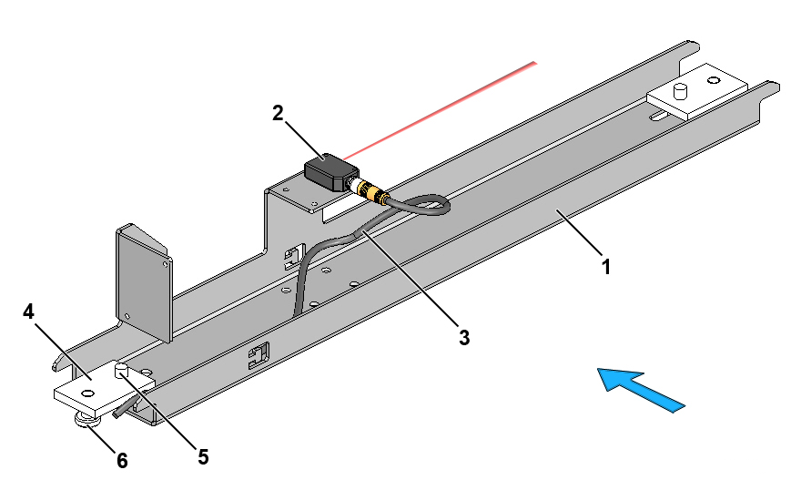
Fig. 1-1 Distributed synchronization photocell, complete
1. | Bracket for distributed synchronization photocell | 4. | Fixing plate
2. | Synchronization photocell | 5. | Guide screw
3. | Cable for photocell | 6. | Fixing screw

Preparation necessary
Installation of the following parts of the sorter must be complete before the distributed synchronization photocell is installed:
- Supports
- Sections

Tools
Supplied Customer Tool Kit TT/CB 4000

Guides
- Electrical component location drawing
- I/O list

Installation guide
.1 Position the synchronization photocell on the mounting flanges of the cable trays in the sorter frame in accordance with the electrical component location drawing.
.2 Prepare the photocell bracket for installation by pushing the two fixing plates towards the middle of the bracket as shown in Fig. 1-2.
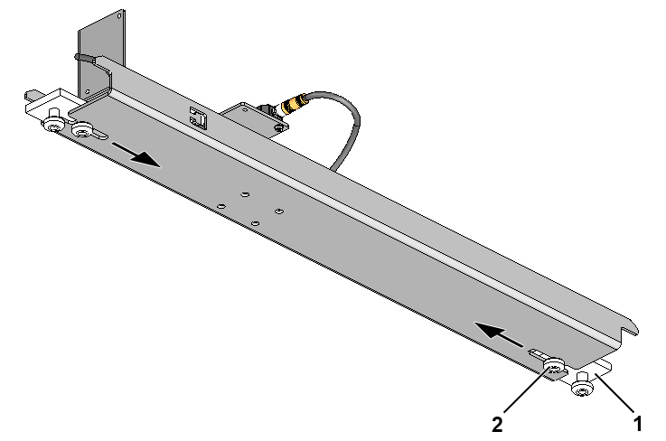
Fig. 1-2 Preparation of distributed synchronization photocell for installation
1. | Fixing plate
2. | Guide screw, Torx 45, M8x16

.3 Install the distributed synchronization photocell between the sorter section’s cable trays from below as shown in Fig. 1-3. Install the distributed synchronization photocell from above if necessary for access reasons.
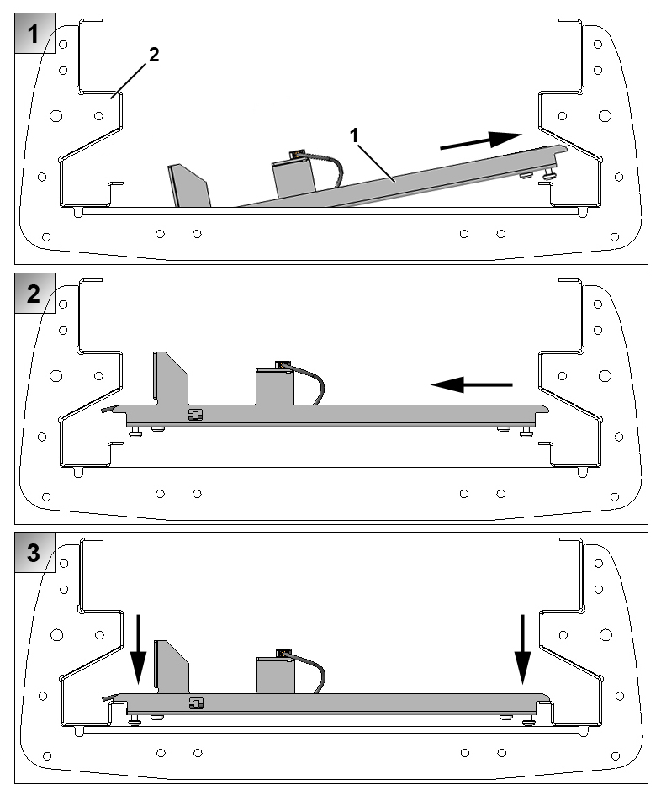
Fig. 1-3 Positioning of distributed synchronization photocell in sorter section (as seen in direction of travel)
1. | Distributed synchronization photocell
2. | Sorter section

.4 Push the two fixing plates in over the cable tray’s mounting flanges and tighten the two fixing screws and guide screws as shown in Fig. 1-4.
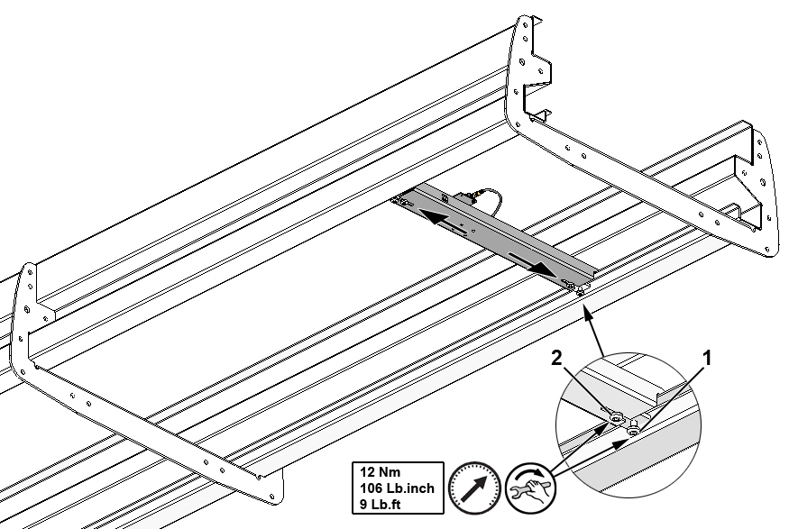
Fig. 1-4 Securing distributed synchronization photocell
1. | Fixing screw
2. | Guide screw

.5 Connect the photocell in accordance with the I/O list.
.6 Secure the photocell cable with cable ties as shown in Fig. 1-5.
Please note that there should be at least a 20 mm gap between the photocell cable and the edge of the bracket once the cable has been secured.
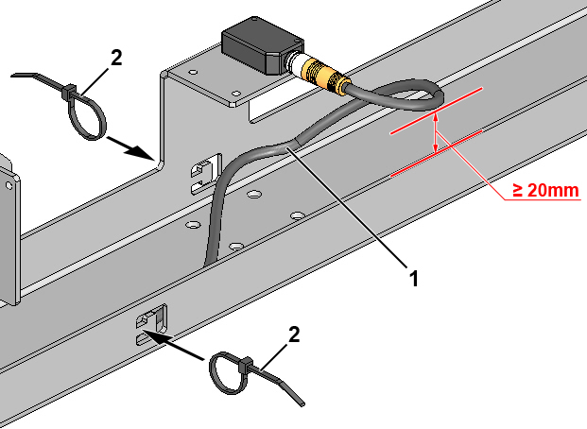
Fig. 1-5 Securing photocell cable
1. | Photocell cable
2. | Cable tie, 3.5 x 150 mm

